**Recalling a Submitted Form in the ME Forms Portal**

<https://student.gradforms.me.gatech.edu/>

If you have made a mistake and need to recall a form:

1. Go to my Forms:

1. Click on the form that you wish to recall:

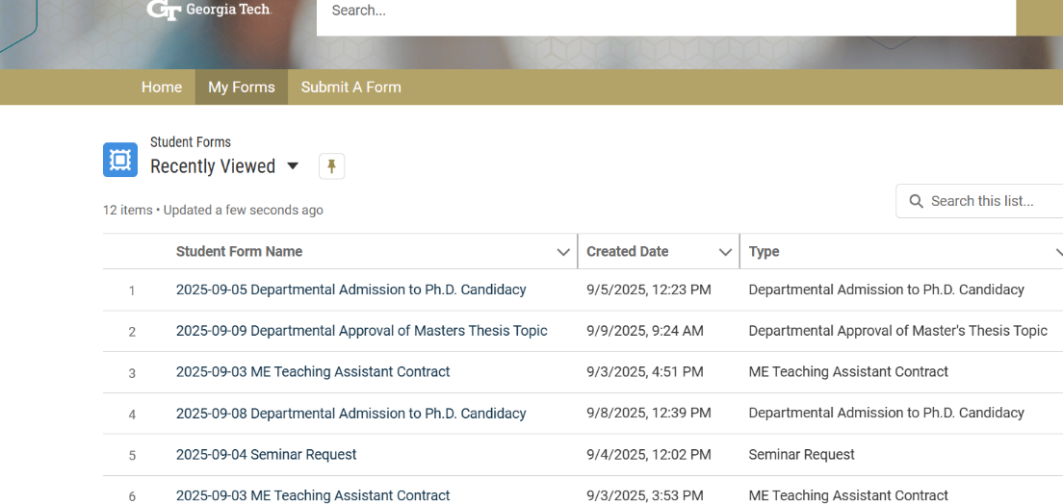

1. Click on the Recall button on right side corner:

1. Once the form has been recalled, the status will change to “Recalled” in the My Forms dashboard.